**ASSIGNMENT - 4**

|  |  |
| --- | --- |
| Team ID | PNT2022TMID32810 |
| Name | SMART SOLUTIONS FOR RAILWAY SYSTEMS -IOT |
| Team Leader Name | SUBIKSHAA |
| Team Members Name | RITHESWETHA, SUBAPREETHI, VASUNTHARA |
| Maximum Marks | 2 Marks |

**QUESTION :**

Write code and connections in wokwi for ultrasonic sensor. Whenever distance is less than 100 cms send “alert” to IBM cloud and display in device recent events.

**CODE :**

#include <WiFi.h> // library for wifi

#include <PubSubClient.h> // library for MQTT

//------- credentials of IBM Accounts ---------

#define ORG "prbqrn" // IBM organisation id

#define DEVICE_TYPE "Ultrasonic" // Device type mentioned in ibm watson iot platform

#define DEVICE_ID "Assignment" // Device ID mentioned in ibm watson iot platform

#define TOKEN "6qL3DUu-zuo8yPl7tS" // Token

#define speed 0.034

#define led 14 String data3;

int LED = 4;

//---------------------------------- customise above values -----------------------------------------------------

char server[] = ORG ".messaging.internetofthings.ibmcloud.com"; // server name

char publishTopic[] = "iot-2/evt/sreedhar/fmt/json"; // topic name and type of event perform and format in which data to be send

char topic[] = "iot-2/cmd/led/fmt/String"; // cmd Represent type and command is test format of strings char authMethod[] = "use-token-auth"; // authentication method char token[] = TOKEN;

char clientId[] = "d:" ORG ":" DEVICE_TYPE ":" DEVICE_ID; //Client id

//---------------------------------------------------------------------------------------------------------------------

WiFiClient wifiClient; // creating instance for wificlient

PubSubClient client(server, 1883, wifiClient); // calling the predefined client id by passing parameter like server id,port and wifi credential

const int trigpin=5; const int echopin=18;

String command;

String data="";

long duration;

float dist;

void setup()

{

**Serial**.begin(115200); pinMode(led, OUTPUT); pinMode(trigpin, OUTPUT); pinMode(echopin, INPUT); wifiConnect(); mqttConnect();

}

void loop() { bool isNearby = dist < 100;

digitalWrite(led, isNearby);

publishData();

delay(500);

if (!client.loop())

{

mqttConnect(); // function call to connect to ibm }

}

/* --------------------------------------------------retrieving to cloud-----------------------------------------------------*/

void wifiConnect()

{

**Serial**.print("Connecting to ");

**Serial**.print("Wifi");

WiFi.begin("Wokwi-GUEST", "", 6);

while (WiFi.status() != WL_CONNECTED)

{

delay(500);

**Serial**.print(".");

}

**Serial**.print("WiFi connected, IP address: ");

**Serial**.println(WiFi.localIP());

}

void mqttConnect()

{

if (!client.connected())

{

**Serial**.print("Reconnecting MQTT client to "); **Serial**.println(server);

while (!client.connect(clientId, authMethod, token))

{

**Serial**.print(".");

delay(500);

}

initManagedDevice();

**Serial**.println();

}

}

void initManagedDevice() { if (client.subscribe(topic))

{

**Serial**.println("IBM subscribe to cmd OK");

} else

{

**Serial**.println("subscribe to cmd FAILED");

}

}

void publishData()

{

digitalWrite(trigpin,LOW); digitalWrite(trigpin,HIGH); delayMicroseconds(10); digitalWrite(trigpin,LOW); duration=pulseIn(echopin,HIGH); dist=duration*speed/2; if(dist<100)

{

digitalWrite(LED,HIGH);

String payload = "{\"Alert Distance\":";

payload += dist; payload += "}";

**Serial**.print("\n");

**Serial**.print("Sending payload: "); **Serial**.println(payload);

if (client.publish(publishTopic, (char*) payload.c_str())) // if data is uploaded to cloud successfully,prints publish ok else prints publish failed

{

**Serial**.println("Publish OK");

}

}

if(dist>100)

{

digitalWrite(LED,HIGH); String payload = "{\"Distance\":"; payload += dist;

payload += "}";

**Serial**.print("\n");

**Serial**.print("Sending payload: "); **Serial**.println(payload);

if(client.publish(publishTopic, (char*) payload.c_str()))

{

**Serial**.println("Publish OK");

} else

{

digitalWrite(LED,LOW);

**Serial**.println("Publish FAILED");

}

}

}

**OUTPUT :**

Code simulation on wokwi

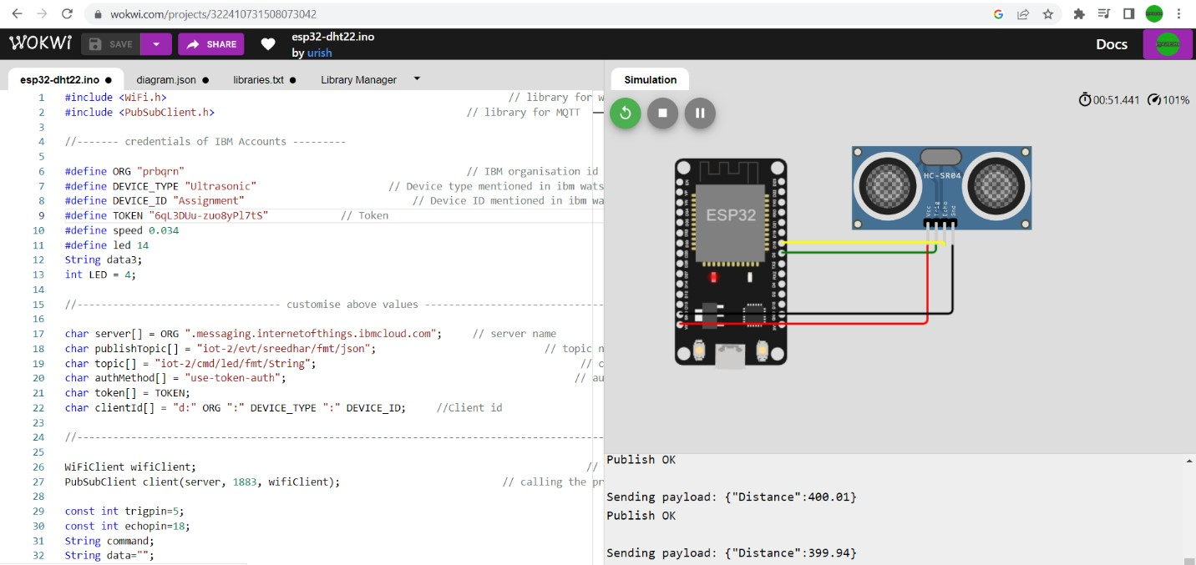

Data sent to IBM Cloud with distance

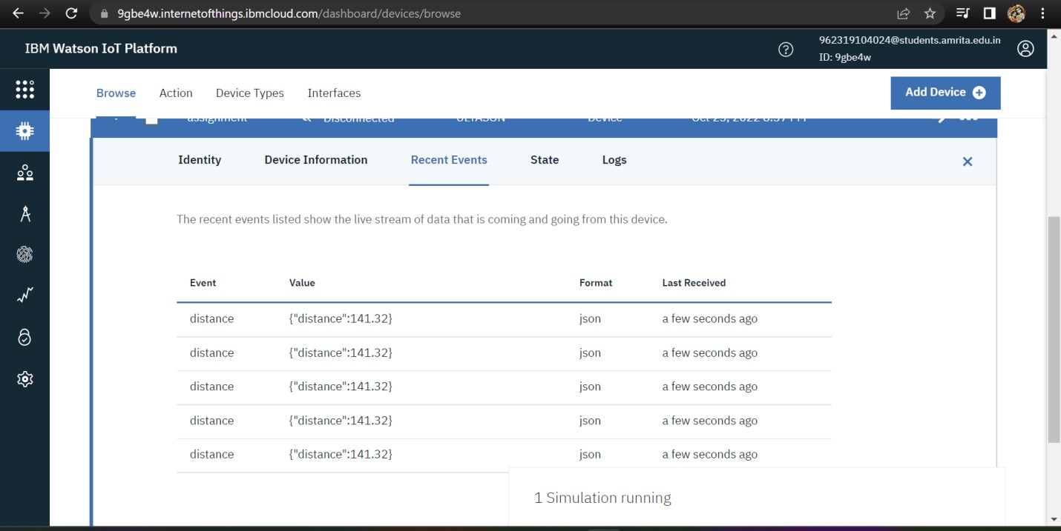

**Link** : https://wokwi.com/projects/346676889639715411